Lab 1: PCB Fabrication, VNA Calibration, and Characterization of Lumped Elements (Resistor, Inductor, Capacitor, and RF Choke)

Objective:
The purpose of this laboratory is to learn how to fabricate printed circuit board (PCB) using chemical etching, how to perform Through-Reflect-Line (TRL) and Short-Open-Load-Through (SOLT) calibration, and how to characterize lumped elements.

Pre-Laboratory:
- Read “Agilent AN 1287-3 Applying Error Correction to Network Analyzer” to learn SOLT calibration.
- Read “Agilent 8510-8A Network Analysis Applying the 8510 TRL Calibration for Non-Coaxial Measurements” to learn TRL calibration.
- Read “Agilent ADS Line Calculator Tutorial.” Use it to calculate the effective permittivity. Determine the length of your TRL calibration standards.
- Bring a USB thumb drive to save your data. Usually you want to save the *.s2p file and process these data using software such as Matlab. In most cases, please do not save the screen shot and put it in your lab report. This is not professional.

Equipment and Materials:
- Agilent Performance Network Analyzer (PNA).
- SMA connectors, resistors, capacitors, inductors, and 32-mil-thick Rogers RO4003 substrate (you can find its material property from Rogers Corp. Website).

Introduction to PCB Fabrication:
- Print the circuit layout on a specially-made transfer paper (Toner Transfer System). It’s a 5-mil-thick paper that has a special coating of Dextrin applied by a very large and expensive knife coater, which applies a very thin and uniform coat.
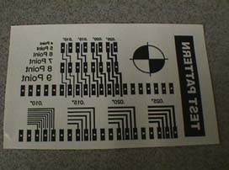
- Cut the transfer paper to appropriate size such that it has all the layouts on it, place the paper on PCB (plastic protection layer has been stripped), and tape it.
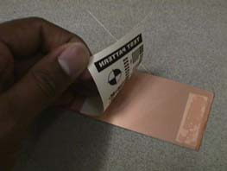
- Now send the board through the Toner Image Applicator (TIA). You may do it twice to get better adhesion.
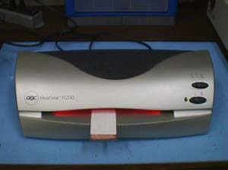
- Once the board comes out of the TIA, place it in water to soak until the paper softens and allows you to peel off, leaving the ink on the board.
- Place a piece of Green TRF paper over the board covering all the layouts and tape it.
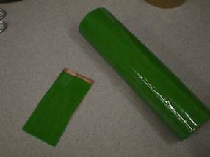
- Send the board through TIA once again. Peel the Green TRF. The green TRF sticks only over the toner image. This forms a double protective layer on the copper.
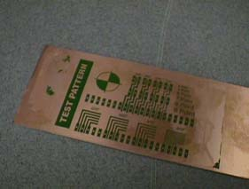
- Tape the backside of PCB to prevent etching the ground plane. Place the PCB in the beaker containing etching solution prepared by the TA. The etchant is heated to approximately 90ºC (heater setting of 4). Leave it in the etchant until the entire copper, except for the layouts, is etched off. Etching time is dependent on the beaker temperature, the age of the etchant, number of boards previously etched, and stirring.
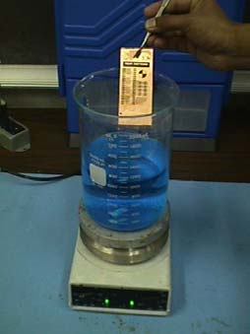
- Wash this board with acetone to remove the black ink thereby leaving copper layouts on the board.
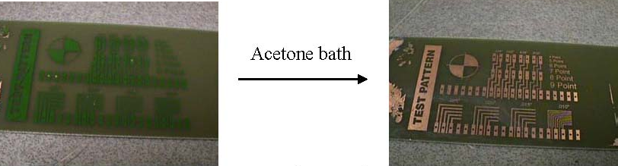
- Finally, remove the tape on the ground plane.

Procedure:
  - Design your TRL calibration kits on the Rogers RO4003 substrate. The characteristic impedance of these lines should be 50 ohm. The center frequency is 1 GHz. You may use CorelDraw to create your circuit layout as shown below. Determine the right length of the open, through, and line standards following the instructions in the pre-lab. You need to present your design procedure including Corel Draw layout in your lab report to receive grades. TA may pick up one group’s design and fabricate one set of calibration standards since each standard set needs five SMA connectors and it will be uneconomical to fabricate one set for each group.
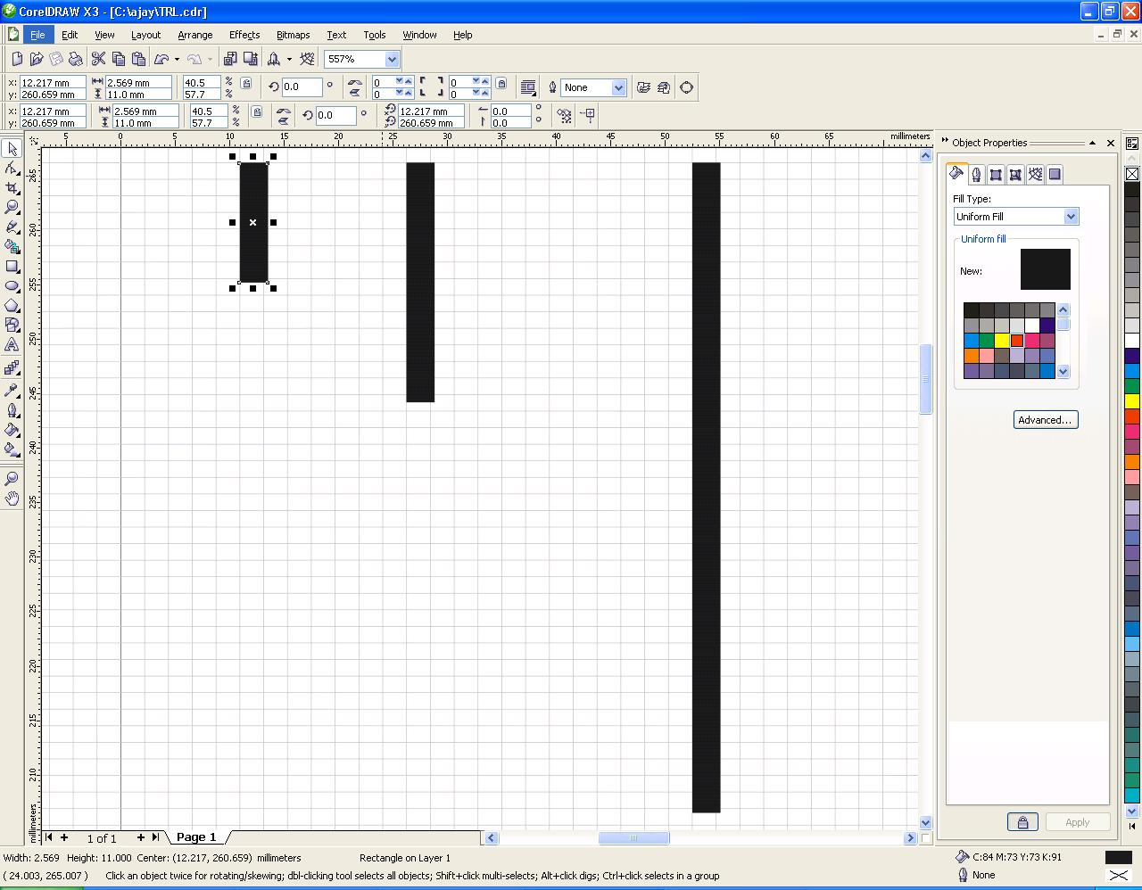

  - TRL Calibration:
- Set up the appropriate frequency range. What is the maximum frequency range in which your TRL calibration standards can give you accurate calibration?
- Perform the TRL calibration. Save the calibration using name “TRL”.
- Check whether you have done a good calibration. Measure the calibrated responses of your through, line, and reflect standards. Do they meet your expectations? Explain. Compare the calibrated and non-calibrated responses on the same graph and explain.
- If you results are not satisfactory, check your board, transmission lines, and connector soldering (which is usually neglected).

- Save the S parameters of the through, line, and reflect before and after calibration.

3) SOLT Calibration:
- Perform One-Port SOLT calibration. Save the calibration using name “SOLT”.
- Check whether you have done a good calibration. Measure the calibrated responses of the Short, Open, Load standards. Do they meet your expectations? Explain. Compare the calibrated and non-calibrated responses on the same graph and explain.

- Save the S parameters of the short, open, and load before and after calibration.

3) Measurement of Lumped Elements:
- The TA has designed a circuit layout in which you can place a chip resistor. One end of the resistor should be placed at the reference plane and the other end should be grounded using a through via. (Note that the grounding path should be as short as possible, why?)
- Use the same layout for a chip capacitor.
- Use the same layout for a chip inductor.
- Use the same layout for a low-frequency capacitor.
- A different layout was designed to measure ADCH-80A RF Chokes.
- Measure all these components using both TRL and SOLT calibrations. You may quickly switch between different calibrations states without disconnecting your devices.

- Save S₁₁ of the resistor, capacitor, inductor, low-frequency capacitor, and RF choke using SOLT and TRL calibrations. Saved S₁₁ should be a complex number.

Laboratory Report :
- You need to answer all the questions in the lab procedure.
- You can present S parameters using Smith Chart, X-Y graph (magnitude or phase, real or imaginary). It is your decision regarding which format to use. But the one you pick should help you explain the results clearly.
- Why do you use TRL instead of SOLT calibration for the measurement? Point out your reference plane for each case on the picture. Which kind of errors if you use SOLT calibration? Can you use theory to compensate the errors? How?
- Show how you determine the TRL standard length and maximum frequency range.
- Show the calibrated responses of the through, line, and reflect using TRL cal. Comment on your results.
- Graph the S parameters of the lumped elements using both calibration methods. Also extract the resistance, capacitance, and inductance value of each component. Please note that you need to also plot the component values versus frequency. Comment on your results.
- Can you use the low-frequency capacitor for 1 GHz circuit? Why?
- Does the RF choke behave like an open at 1 GHz? You will use it for your amplifier biasing.
- Is the chip component performance good enough for 1 GHz applications?
- The grounding vias will introduce parasitic inductance. How to minimize this inductance? (extra points: characterize the parasitic inductance using any full-wave simulation software such as momentum in ADS.)

